Dataa:
100*2, continuous
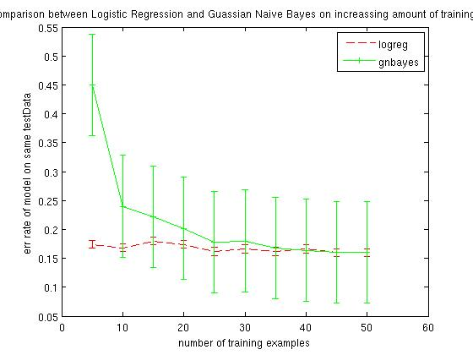

datab:
100*2, continuous
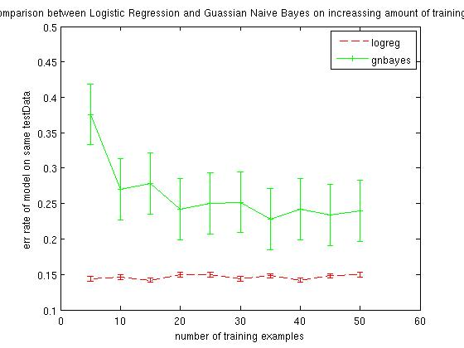

datac
100*2 continuous
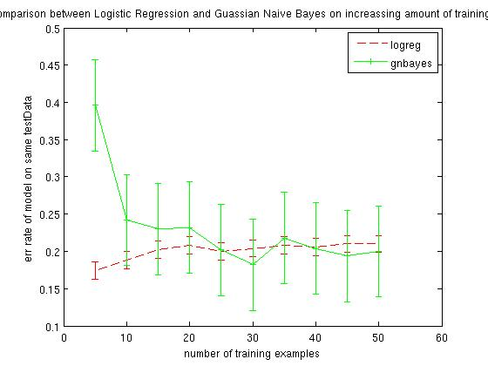

breast
569*30 continuous
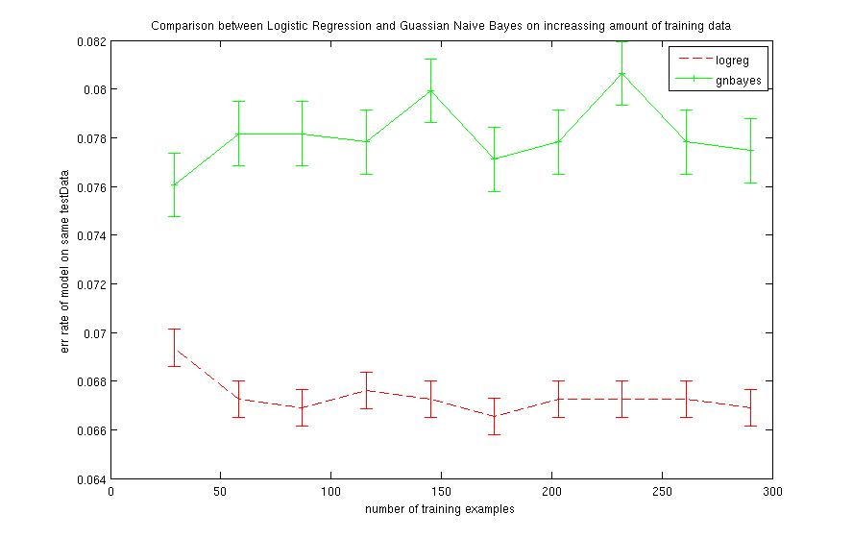
heart
270*13
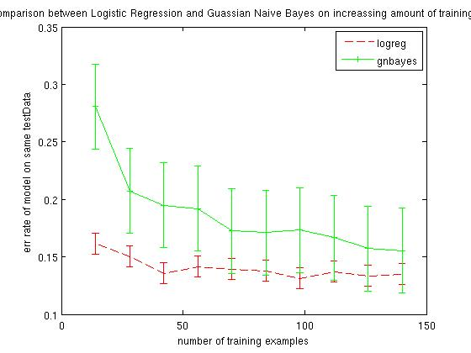

congress
435*16 discrete
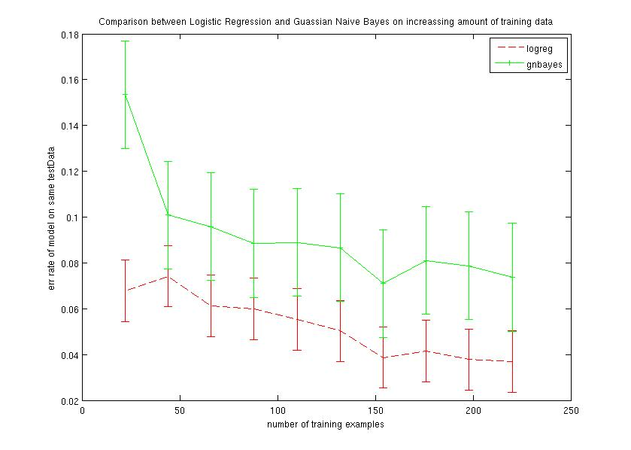
nbayes!!!!!!!!!!!!!!!!!!!!for discrete values
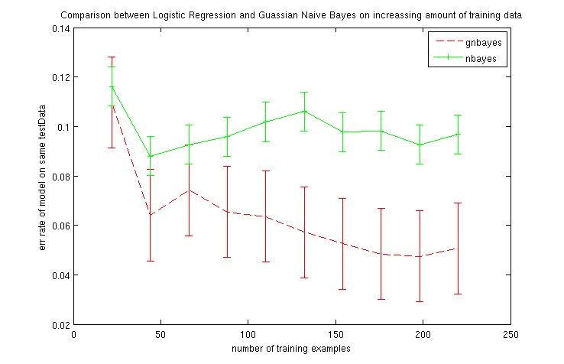

kevskp
3196*36, discrete

